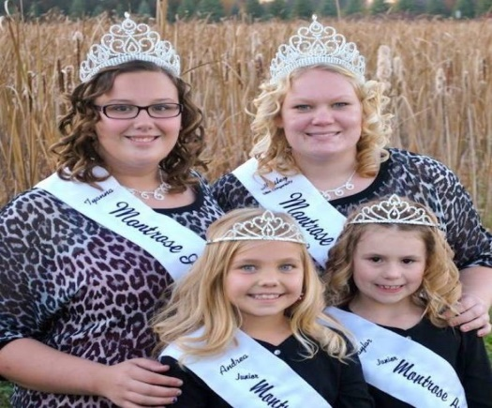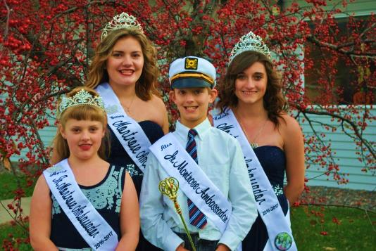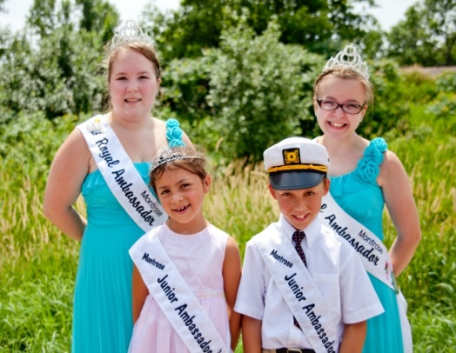

**We Want You**

If you have any questions or want more

information visit our website at

<http://montroseroyalty.yolasite.com/>

Or Facebook page

<https://www.facebook.com/montroseroyalty>

Contact-Cori Potter 612-501-3156  
Email: montroseroyalambassadors@gmail.com

Being an Ambassador for Montrose you will:

* Meet new friends
* Improve public speaking skills
* Ride on a float
* Develop leadership skills
* Volunteer at many different events
* Represent the City of Montrose
* Build your confidence and self-esteem
* Wear a crown and gown
* Earn a scholarship
* Have a chance to be an Aquatennial Queen of the Lakes Candidate
* Have a time of your life!

Are you 17-20 years old and want to be an Ambassador?

Here is your chance; the Montrose Ambassador program is looking for candidates for this upcoming year 2017-2018